**Entity Relationship Model:**

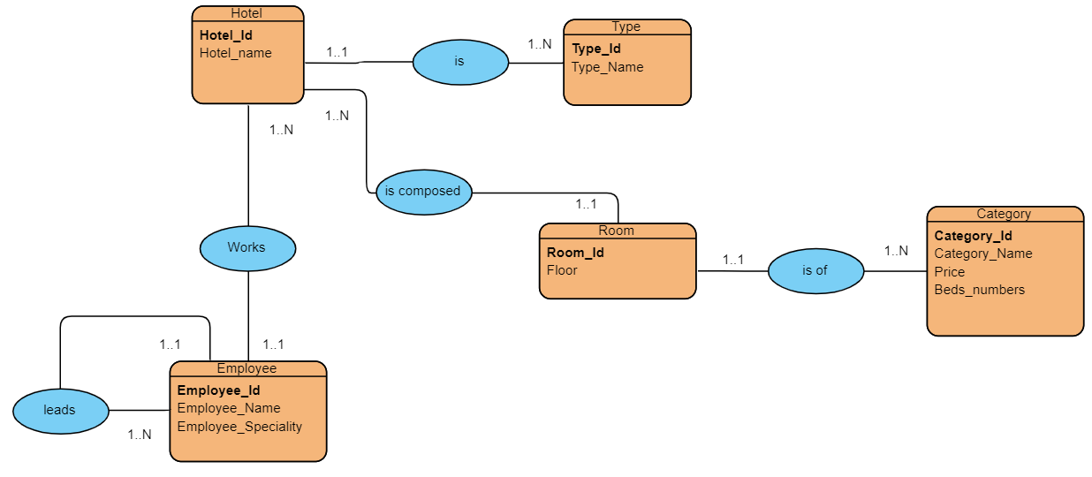

**Relational Model:**

Hotel (**Hotel_id**, Hotel_name, **#Type_id**)

Type (**Type_id**, Type_name)

Employee (**Employee_id**, Employee_name, Employee_speciality, **#Hotel_id**, **#Director_id**)

Room (**Room_id**, Floor, **#Hotel_id**, **#Category_id**)

Category (**Category_id**, Category_name, Price, Beds_numbers)